WHAT WOULD YOU SAVE?
IF YOU COULD SAVE ONLY ONE GENETIC RESOURCE, WHAT WOULD YOU SAVE? Why?
Then turn the card to read more

- Heat tolerance  SAHIWAL  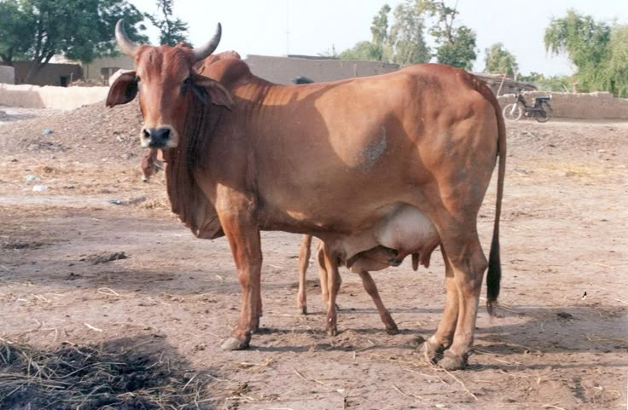  Thrives where heat challenges productivity | - Disease resistance  N’DAMA  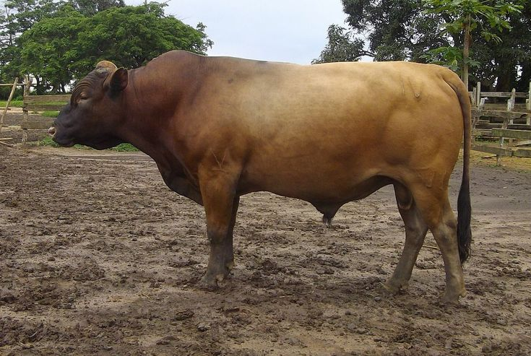  Survives where disease limits cattle production
Why the trait matters  Heat stress reduces fertility, growth, milk yield and survival. Heat-tolerant cattle provide an important genetic resource as temperatures rise. Heat tolerance is an insurance trait for the future.  Why biodiversity matters  A highly productive temperate breed may outperform Sahiwal under cool, well-managed conditions, BUT its performance can deteriorate under severe heat. | Why the trait matters  N’Dama cattle are renowned for their trypanotolerance, allowing cattle production in environments where African animal trypanosomiasis constrains susceptible breeds.  Why biodiversity matters  Selecting only for production can remove valuable disease-resistance genes. BUT a lower-output animal carrying resistance may be more valuable when disease pressure changes.
- Drought adaptation  BORAN  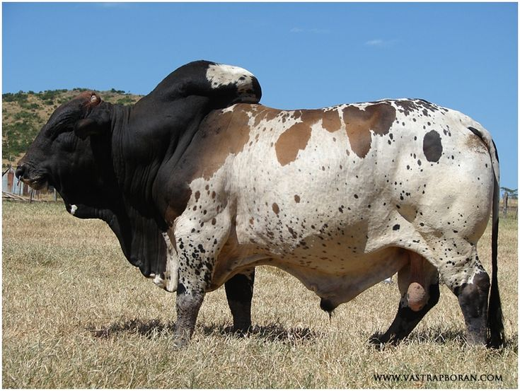  Produces under water and feed scarcity | - Feed efficiency  JERSEY  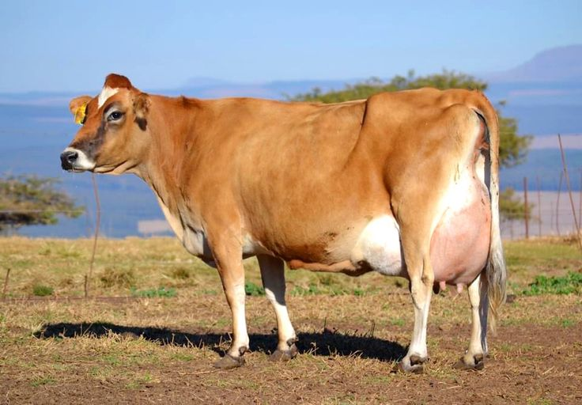  More milk solids from a smaller feed requirement
Why the trait matters  Boran cattle are adapted to hot, dry environments and can maintain production and reproduction under limited water and forage availability.  Why biodiversity matters  Under favourable conditions, high-producing cattle may produce more. During drought, HOWEVER, survival and reproduction can become more important than maximum output. Adaptation provides resilience when conditions deteriorate. | Why the trait matters  Jersey cattle produce milk with high concentrations of milk solids relative to their body size and can be efficient where feed resources are limited.  Why biodiversity matters  Maximizing litres of milk alone can favour larger animals with greater maintenance requirements. HOWEVER, efficiency is a different production strategy from maximum volume
- Productivity  HOLSTEIN-FRIESIAN  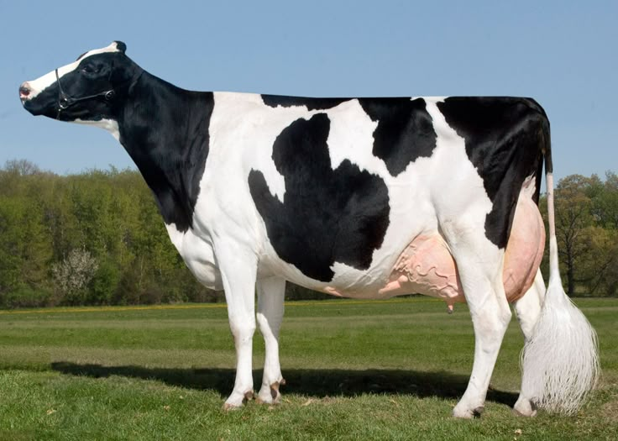  High-output specialized production | - Cultural value  WHITE FULANI (BUNAJI)  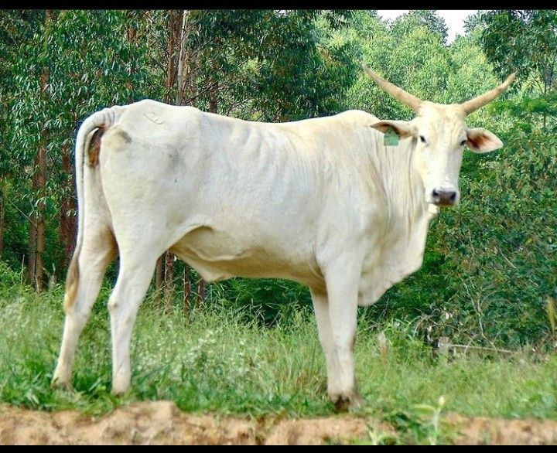  Livestock as heritage, livelihood and identity
Why the trait matters  Holsteins demonstrate the enormous gains possible through sustained selection for milk production in suitable production environments.  Why biodiversity matters  High productivity is extremely valuable, BUT it is only one component of fitness. A portfolio should contain high-output genetics alongside animals adapted to stresses that high-production systems may not tolerate. | Why the trait matters  Cattle are not merely biological production units. White Fulani cattle are embedded in livelihoods, pastoral systems, traditions, wealth and cultural identity across West Africa.  Why biodiversity matters  Biodiversity includes the relationship between genetic resources and the societies that maintain them. IF conservation focuses exclusively on economic productivity, culturally important populations can disappear.
- Ecosystem adaptation  NGUNI  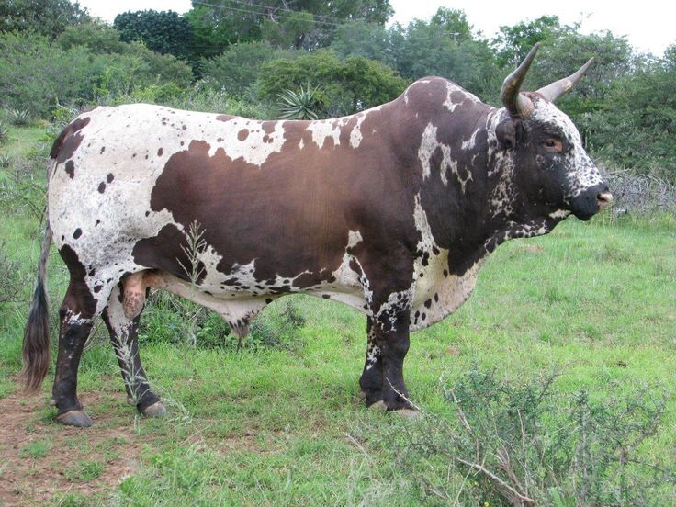  Adapted to African landscapes and variable resources | - Ornamental value  ANKOLE-WATUSI  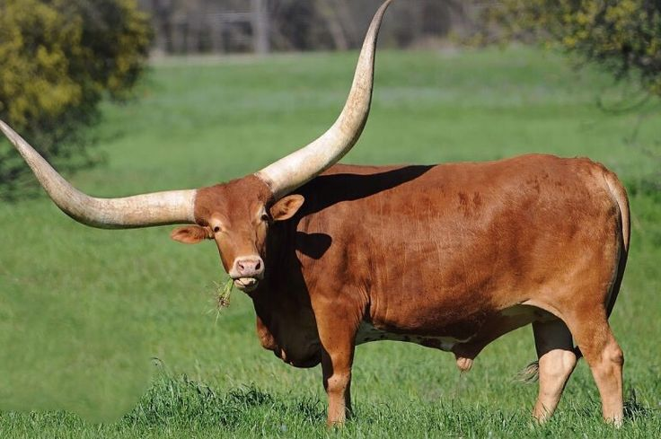  Living genetic heritage with extraordinary horns
Why the trait matters  Nguni cattle have evolved within Southern African environments and are valued for resilience, hardiness and adaptation to local production conditions.  Why biodiversity matters  There is no single optimal cattle phenotype for every ecosystem. Local adaptation is itself genetic capital. | Why the trait matters  Its exceptionally large horns and distinctive appearance represent a remarkable component of cattle genetic and cultural heritage.  Why biodiversity matters  Traits that have little immediate production value may nevertheless carry cultural, historical and genetic significance. Once a unique population disappears, its evolutionary history cannot simply be recreated.

The value of a genetic resource is not determined only by how well it performs today, but also by the traits it carries that may become essential tomorrow

What will it look like
